**Name of Journal:** *Vocation, Technology & Education*

**Manuscript Type:** Original Article, Review Article, *etc*.

**Title** (no more than 18 words)

Author 1,#, Author 1,#, Author 2, Author 2,*

1Department, School/Institution, City and Postcode, Province, Country

2Department, School/Institution, City and Postcode, Province, Country

#These authors contributed equally to this work.

**\*Corresponding Author:** Name, Department, School/Institution, Road/Street, District, City and Postcode, Province, Country. Email: ; https://orcid.org/

**Abstract**

Original articles and reviews require a one-paragraph abstract of no more than 250 words; other short articles such as editorials and commentaries do not require an abstract.

**Key words:** No more than 8 article-related words, separated by commas.

**Article text**

* The first paragraph is usually titled "**INTRODUCTION**" and the last paragraph is usually titled "**CONCLUSION**".
* Usually there are up to four levels of headings in an article, with the following formatting requirements:

1. First level: **ALL LETTERS CAPITALIZED, BOLDED, AND NOT ITALICIZED**

1.1. Second level: ***Capitalize the first letter of subheading, bold, and*** ***italic***

1.1.1. Third level: *Capitalize the first letter of subheading, italicize, and not bold*

1.1.1.1. Forth level: Capitalize the first letter of subheading, underlined, not bold, and not italic

* All abbreviations need to be provided with full spelling when they first appear. Such as Vocation, Technology & Education (VTE). All abbreviations that appear in figures and tables need to be listed with full spelling. Such as: 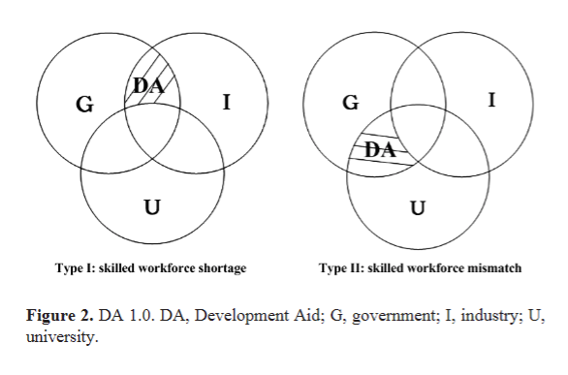
* Arabic numerals cannot appear at the beginning of a sentence. Such as: “32 students participated in the study” should be changed to “Thirty-two students participated in the study” or “A total of 32 students participated in the study”.
* Citations appear in narrative form or fully parenthetical form. In a narrative citation, the author surname or surnames appear as part the sentence. The publication year may either be set apart in parentheses after the surname(s) or be integrated into the sentence. (APA 7th edition):

1. Parenthetical citation of a work with one author: One of the most studied frameworks for PM is curriculum-based measurement (Deno, 1985).
2. Narrative citation: This phenomenon occurs frequently in nature, according to Singh and Harris (2018).
3. Parenthetical citation of a work with two authors: This phenomenon occurs frequently in nature (Singh & Harris 2018).
4. Parenthetical citation of a work with three or more authors: The average 2-week test-retest reliability is 0.93 for students aged 6-7 (Torgesen et al., 2012).
5. Parenthetical citation of multiple works: (Gullo & Impellizeri, 2022; Missall et al., 2019).
6. Secondary source: (Fodor, 1981, as cited in Neuweg, 2000) or Fodor (1981, as cited in Neuweg, 2000).
7. Parenthetical citation for works with the same author and same date: (Boysen, 2015a, 2015b).

**DECLARATIONS**

**Acknowledgments**

***Author contributions***

All authors have read and approved the final version.

***Source of funding***

This research received no external funding.

***Ethical approval***

Not applicable./The study protocol was approved by...

***Informed consent***

Not applicable./Written informed consent was obtained from the participants for publication./The authors declare that they have obtained appropriate informed consent from persons or their guardians appeared in the figures to be published in this article. They have given their consents for their images to be published in the journal./The participants were informed that the interview data were only used for research purposes, and their information would be anonymized when presenting the research result. Moreover, they are also allowed to stop the recording at any moment during the interview, and they can refuse to respond to any question asked during the review.

***Conflict of interest***

The author has no conflicts of interest to declare./** is the ** of the journal. The article was subject to the journal’s standard procedures, with peer review handled independently of the editor and the affiliated research groups./** is the ** of the ***.

***Data availability statement***

No additional data./Data used to support the findings of this study are available from the corresponding author upon request./All data has been included in this paper.

**References**

* **Standard journal article**: Al Otaiba, S., Connor, C. M., Folsom, J. S., Greulich, L., Meadows, J., & Li, Z. (2011). Assessment data-informed guidance to individualize kindergarten reading instruction: Findings from a cluster-randomized control field trial. *The Elementary School Journal*, *111*(4), 535-560. https://doi.org/10.1086/659031
* **Books of personal author(s)**: Parija, S. C. (2008). *Textbook of Medical Parasitology*. All India Publishers and Distributors.
* **Chapter in a book**: Mcdonalds, A. (1993). Practical methods for the apprehension and sustained containment of supernatural entities. In G. L. Yeager (Ed.), *Paranormal and occult studies: Case studies in application* (1st ed., pp. 42-64). OtherWorld Books. https://doi.org/10.1037/0000132-000
* **Newspaper Article:** Feder, B. J. (2002, July 18). I.B.M. beats forecasts but with signs of weakness. *The New York Times*, C1.
* **Thesis**: Schachar L. M. Financing the Future: The Emerging Role of Income Share Agreements in Higher Education*.* University of Pennsylvania (Thesis/*** Dissertation). 2019.
* **Non-English references [Translate the title into English and mark it in square brackets]**: Yu Y. H. & Zhang X. (2021). [On the generation mechanism and governance paths of postgraduates' academic misconduct from the perspective of bounded rationality]. *Journal of Graduate Education,* *66*(6), 35-41.
* **Website (Accessible URLs and access times are indispensable):** Magi, T. (2019, July 24). Business research assistant. University of Vermont Libraries. Retrieved November 19, 2019, from http://researchguides.uvm.edu/business

**Figure**

* Images should be no less than 300 DPI.
* Capitalize the first letter of the first word when a phrase or combination of words appears in the picture. Such as “Vocational Education” should be written as “Vocational education”
* All abbreviations that appear in figures need to be listed with full spelling. 

**Table**

* Tables should be three-line tables and bold the header text
* Tables should be editable in word
* All abbreviations that appear in tables need to be listed with full spelling.

**Table 1:** **Title**

|  |  |
| --- | --- |
| **\*\*\*** | **\*\*\*** |
| 1 | A |
| B |
| C |
| - (There should be no blank item in the table, fill it with hyphen) |
| NA |

NA, not applicable.